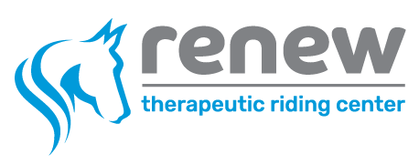
Student Handbook

5080 146th Avenue
Holland, MI 49423
For further information, contact:
(616) 227- 3639 ext. 3

programs@renewtrc.org

Our Mission:
Our mission is to enhance the well-being of individuals in our community through the physical, cognitive, and emotional benefits of therapeutic horsemanship. At Renew, each rider has the opportunity to go beyond their disability, inability, fear, or reality. We encourage and support dreams by offering therapeutic horsemanship activities to fulfill our mission, striving to help riders develop their maximum potential in a caring and fun environment that empowers the rider in ways different from traditional therapy.
Renew Therapeutic Riding Center is a 501(c)(3) non-profit organization that is focused on improving the lives of all its riders. We are a Premier Accredited Center with PATH International, the only accredited therapeutic riding center in West Michigan.
Welcome to Renew TRC:

We are glad that you and/or your rider have interest in learning more about Renew TRC programming! We strive to provide high quality equine-assisted therapies to individuals in our community. We look forward to having you as a part of the Renew TRC family!

Our Team:

Each therapeutic riding lesson is taught by one of our PATH Intl. Certified Instructors who come from a variety of professional backgrounds. Our instructors work with riders, their families/caregivers, or fellow healthcare and educational professionals to develop a plan to address each rider’s needs. With an emphasis on the safety, well-being, and respect of the student and the horse, our trained volunteers assist the instructors in implementing the riding goals for each lesson. Instructors document outcomes and maintain progress notes for each session. All files are maintained securely on-site in locked file cabinets in compliance with PATH Intl.

Our History:

The riding program began in 2009 by founders, Jodi Geerlings and Phyllis DeHaan, as a result of a lifelong dream to offer therapeutic riding lessons to those who could benefit from this service. In 2011, we moved to Rusty Spurs Equestrian Center, where Jodi and Phyllis partnered with Tom and Kelly Rozema to begin therapeutic riding at this location. The name was then changed to Renew Therapeutic Riding Center, taking the notion of renewal from Isaiah 41:30.

In 2013, the Board hired Melissa Conner as Executive Director and as an Advanced Instructor, and Renew began another stage of growth, doubling our number of students served and volunteers involved in the program. This growth necessitated searching for additional space and arena time than was currently available. In late 2014, Renew began a Capital Campaign to raise funds to build our own facility by repurposing a large enclosure at the south end of the property at Rusty Spurs. Due to the generosity of many, including a major grant of $30,000 from the Community Foundation of Holland/Zeeland, the new barn, pasture, heated indoor riding arena, and outdoor arena were completed in January of 2016.

Renew is a 501(c)(3) nonprofit and is governed by a Board of Directors. As a nonprofit, we are dependent upon donations and grant money to meet our budget. Lesson fees cover approximately 30% of operating expenses and we continue to depend greatly upon volunteers to meet the needs of the organization.

Renew Today:
Renew currently serves approximately 90 students each week and has a growing waiting list. We purchased 20 acres at 5080 146th Ave in the Fall of 2018, where new facilities continue to be built as our capital campaign continues for phase 2 (learning center) and phase 3 (horse barn). We moved to our new space in early 2020 and now call it home, complete with a 80’ x 200’ heated indoor arena, viewing room, pastures, fishing pond, riding trails, parking lot, and restrooms on site. We are thankful to continue growing and serving our community on this beautiful landscape!

WHY THERAPEUTIC RIDING?

Horses That Heal
Therapeutic riding opens new pathways of physical, mental, and emotional rehabilitation. The rhythmic and rocking gait of the horse transfers a gentle three-dimensional movement to the rider that relaxes muscles, improves muscle tone, flexibility and balance, and enhances spatial awareness. Accompanied by a team of encouraging volunteers and a supportive horse, self-control, self-esteem, self-confidence, and independence grows. Rehabilitation becomes a joy rather than a chore.

Individuals with disabilities such as cerebral palsy, spina bifida, neuromuscular disorders, post-traumatic stress disorder, acquired brain injury, cognitive limitations, emotional challenges, autism, learning disabilities, and attention deficit disorder, can use riding and learning horsemanship skills to experience an overall improvement in their quality of life.

Healing Attributes of Riding
- Normalizes muscle strength and tone. Improves coordination, freedom of movement, balance, respiration, body awareness, tactile perception, and oral motor control.
- Enhances self-image and confidence. Increases acceptance of unfamiliar experiences. Develops loving relationships with a team of individuals and the horse.
- Increases attention and safety awareness. Enhances comprehension and memory. Improves ability to sequence and follow directions.
- Improves interpersonal communication. Promotes family interaction and broadens social activity. Develops a recreational skill with opportunities to experience success.
Therapeutic Riding
At Renew, the objective is to teach adapted riding skills to the rider. The Professional Association of Therapeutic Horsemanship International (PATH Intl., see pathintl.org for more info) Certified Therapeutic Riding Instructors conduct each lesson. The rider receives all the physical, cognitive, and emotional benefits, in addition to learning how to ride, with the goal of full independence.
Student Information

Lesson Schedule:

We offer therapeutic riding lessons throughout all seasons of the year. Most sessions are 6 weeks long, with one 45-minute lesson each week (2-4 riders per lesson). Registration information is generally emailed to participants a few weeks prior to the start of each session. We follow the Holland Public Schools systems closures and delays.

Upcoming session dates include:
January 18 – February 25 - Session 1
March 8 – April 15 - Session 2
April 26 – June 4 - Session 3
June 14- July 22 - Session 4
August 2 – September 10 - Session 5
September 20 – October 28 - Session 6
November 8 – December 9 - Session 7

Lesson Cancellation:

Renew prefers at least a 24 hour notice by phone to (616) 227-3639 ext. 3 if a rider needs to cancel a scheduled lesson due to unexpected absence (ie. illness). An email to programs@renewtrc.org in addition to the phone call is preferred. If a student has a treatment, surgery, or injury mid-session, we will pass the credit on to the upcoming session they can attend. Riders who arrive more than 10 minutes late to their lesson may not have the opportunity to ride. Please utilize the cancellation hotline to inform your instructor that you are running behind schedule and they will help determine the best plan with you.

Make-Up Lessons:

At this time, make-up lesson dates will only be offered if the lesson is cancelled by Renew TRC due to weather, or the rider has a medical emergency/related-reason during their session. If scheduling does not allow make-up, credit may be given to the following session attended by the student, if deemed appropriate by staff. We cannot guarantee the rider will be given their regular horse, time, or instructor during our provided make-up dates.
No Shows:

If you fail to show up for your scheduled lesson, you will still be charged for the lesson with no make-up date option given. Anyone who doesn't call or show up more than twice during a session when they are expected will be dropped from the regular schedule and allowed back in as the schedule permits. Lesson credit will not be given for any no-shows.

Annual Form Updates:

The two required forms for participation in Renew TRC lessons are the Participant Application and the Physician’s Statement. They both can be downloaded from our website: renewtrc.org under the ‘Programs’ tab. The Release of Information Form is only necessary when the rider attends lessons with a school group or group home. With the help of their instructor, all riders participate in a verbal session reassessment of their goals and abilities to add to their rider progress notes. If there are any positive or negative changes in the rider’s health/medical status, please notify the instructor immediately and a Participant Annual Update form will be required. Updated forms are required at least every 3 years, or every year for riders with Down Syndrome.

Confidentiality:

Any information pertaining to the participants is strictly confidential. It is critical that we respect each individual by keeping confidential who participates in the program and what occurs at the center unless given specific permission by an authorized person to share information outside of the Renew TRC community. Confidentiality and respect are considered two of the most basic responsibilities of our staff and volunteers.

Rider Eligibility (weight, age, etc.):

Renew TRC respects the guidelines listed below when making decisions regarding horse selection for the lesson. Each guideline is in place so that every member of the team (horse, rider, volunteer and instructor) may have a safe experience.
*For safety, we ask that riders do not exceed the weight of 250 pounds. Staff of Renew TRC will take into consideration various factors such as rider’s skill set, weight, and stability on the horse in order to provide the best service possible. Each of our horses are evaluated and assigned a maximum carrying weight for balanced and unbalanced riders. Considerations will be made for the horse’s age, health/soundness, stability, equipment available, and appropriateness of volunteers available.
*Each rider will be evaluated as an individual. Considerations will also be made for the rider’s height, range of motion, balance and ability to dismount independently. Our riders must be at least 4 years old and able to self-support their head/neck/trunk for at least 10 seconds. This is for the well-being of the rider.
*Please note that the herd and volunteers at the center are dynamic and due to this fact, we do not always have the means available to safely accommodate every individual who wishes to participate.

Dismissal Policy for Volunteers and Guests:

In accordance with PATH Intl. Standards, Renew TRC has a policy to dismiss any volunteers or guests who become disruptive to horses, staff, or programs.This may include not following barn rules, disrespectful or foul language, uncontrolled behaviors, violating the confidentiality policy, or exhibiting actions or language that endanger horses, volunteers, staff, property owners, neighbors, horse owners, or program participants. This policy is to ensure that the culture and environment at Renew TRC remains safe and secure for all stakeholders.

Once a dismissal occurs, the individual involved will not be welcomed back to the facility unless approved in writing by both the Executive Director and the Board of Directors. If a dismissal occurs, staff members will complete an Incident Report and the Executive Director and Board of Directors will be notified.
Financial Information

Payments:

Lesson fees are to be paid in full during the first week of the session, or weekly payment plans are available if desired. The total cost of a 6-week session is $240 ($40 per lesson). An invoice will be sent to your email for the convenience of online payment, or payments can be mailed or dropped off to the payment box inside the viewing room in the arena.

Scholarships:

Renew TRC Scholarship is a fund that provides students with limited income a chance to participate in our programs, thanks to generous donors from our community! We don’t want finances to be the limiting factor for participation in programs at Renew, so please reach out.

You can download the application on our website at the bottom of the ‘Programs’ tab, or contact Shaina at programs@renewtrc.org for more information. Fund availability may be limited to a certain number of sessions per year, and we ask that student’s receiving a scholarship maintain at least 80% attendance or they will be asked to skip a session before being eligible for scholarship coverage again. Makeup lessons are not typically available to our scholarship covered students.
Riding Information

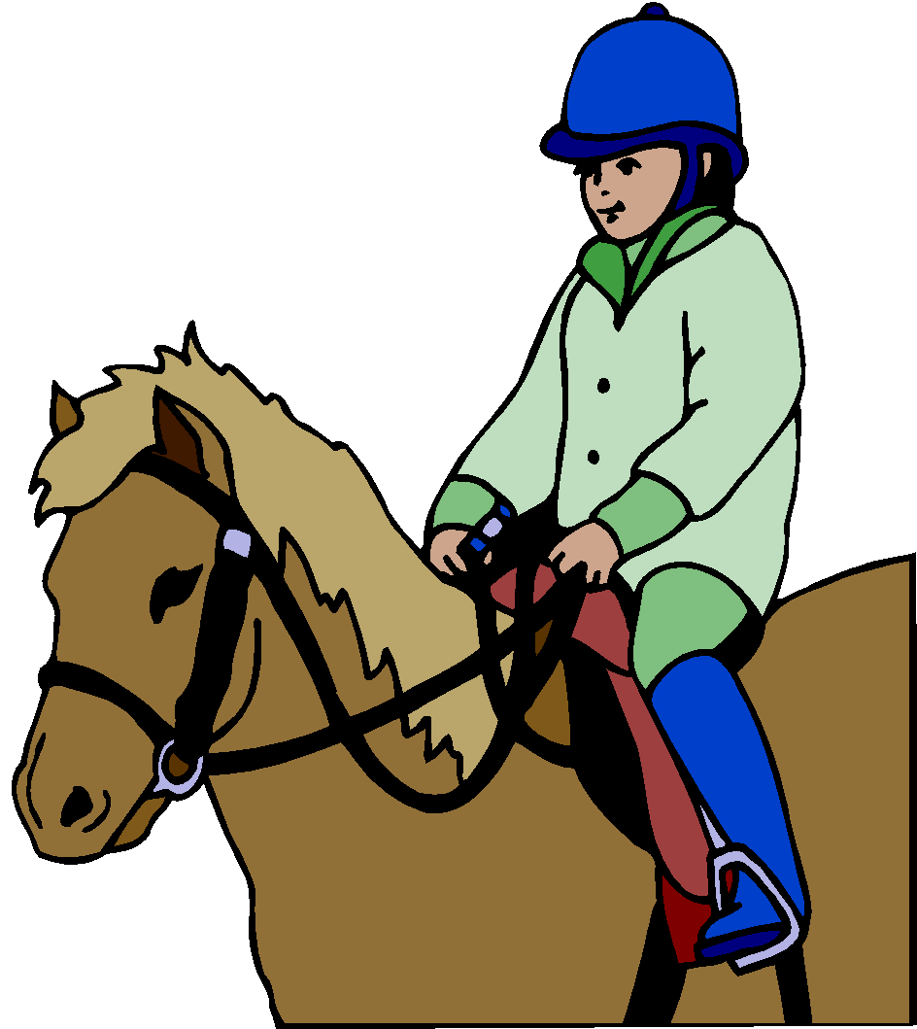

Clothing:

Riders will be in a barn environment, and must dress appropriately. We ask that all riders wear closed toed and heeled shoes such as boots or tennis shoes. An ASTM/SEI helmet is required for each participant. We will provide the helmet for lessons if the rider does not own one. Please check to make sure all headbands and hair ties are worn below the helmet and that jackets are zipped. Also, horses may be wary of any noisy clothing or observers’ umbrellas. Please avoid both noisy and long jewelry.

WINTER/FALL:
In the cool or cold seasons, please be aware that the temperatures at the barn can feel 10° colder than at your house. Layers work best for our riders. Big, bulky coats can hinder the rider and can become a safety issue when dismounting. Gloves can be helpful so long as the rider is not bothered/distracted by them. Please note that when the temperature is below 15 degrees outside, trotting may not be available to ensure our horses can stay healthy and cool down appropriately before being turned out.

SUMMER/SPRING:
In our warm or hot seasons, light colored clothing can help keep the rider more comfortable. Shorts are allowed but can cause the rider discomfort when riding in a saddle. For this reason, long pants like jeans or riding pants are more appropriate. No sandals are allowed. During the lesson the rider may be outside in the sun, so sunscreen is strongly recommended. Insect repellant is also available and recommended.

Inclement Weather:

If the heat index is above 105°F, lessons will be cancelled. All effort will be made to contact the riders whose lessons are affected by this decision. However, if there is a question as to whether we are having lessons, please contact the barn at 616-227-3639. If Holland Public Schools have cancelled classes or evening activities due to snow or extremely low temperature during the winter months, we will cancel lessons. If there is a threat of tornado or severe thunderstorms, please contact us for details concerning lessons.
Frequently asked questions:
Q: Will I/my child ride the same horse every week?
A: We try to keep the rider with the same horse for every session unless there is a health issue with the horse, scheduling conflict, or the instructor requests a horse change based on student needs.

Q: Will I/my child have the same instructor every session?
A: Scheduling and availability of instructors drives much of our assignments. It’s possible that their instructor may change from session to session, but we do our best to avoid this.

Q: Will I/ my child have a private or group lesson?
A: Research has shown that most children benefit from a group experience. Therefore, we attempt to group our riders for the group experience. However, during the initial assessment the instructor may decide that a private lesson is most beneficial for the rider and may be an option based on schedule availability.

Q: I/my child need(s) to take a session off. Can I/my child keep the same lesson time for the next session I/my child ride(s)?
A: Since scheduling requests are made per session/season, we can try to keep to the same lesson time if possible, but this is not guaranteed. Due dates for each session’s registration form will be provided in emails from the Program Manager.

Q: If I know of a lesson I/my child will miss a lesson before the session begins, what should I do?
A: If you know of a pre-planned lesson cancellation, let the Program Manager know at registration so the instructor and volunteer team is aware of the absence. No make-up lessons are available at this time in order to be good stewards of our waitlisted riders.

Q: If the traffic is bad and I think I/my child will be late, what should I do?
A: Call the HOTLINE at (616) 227-3639 ext. 3 and tell us about the traffic and try to get to the barn ASAP. If you think that you cannot make it in time, we will help work out a solution with you.

Q: I would like to help the program but not in lessons, what can I do?
A: We always love help answering phones, helping with mailings, special events, and even dusting or cleaning around the barn. We will direct you or your rider to our Volunteer Coordinator to schedule your volunteer time.

Contacts for Concerns or Questions:

Position | Name | E-mail Address
Executive Director | Melissa Conner | melissa@renewtrc.org
Administrative Assistant | Emily Hill | info@renewtrc.org
Program Manager | Shaina Strikwerda | programs@renewtrc.org
Volunteer Coordinator | Jael Ymker | volunteer@renewtrc.org
Communications Coordinator | Cassie Pelon | communications@renewtrc.org
Farm Manager | Dan Habers | dan.habers@renewtrc.org

Safety Rules and Regulations

Facilities Address and Phone Number:
Renew Therapeutic Riding Center
5080 146th Ave
Holland, MI 49423
Phone: (616) 227-3639

The purpose of this policy is to ensure the safety of participants, the health of the horses and document compliance with standards of the PATH Center Accreditation Manual.

1. No smoking or open flame anywhere on the facility

2. All riders must wear approved helmets while mounted

3. Children must be supervised at all times

4. Speed limit for vehicles is 5 MPH

5. Treat everyone with respect (no offensive language)

6. No activities that may cause a horse to spook (running, roughhousing, etc.)

7. No hand feeding horses or going into paddocks without permission

8. Volunteers and/or students are not able to bring pets/dogs onto Renew TRC Property

9. Obey all posted signs and instruction of staff

Please help keep Renew TRC a safe and caring environment for all!
SAFETY AND EMERGENCY PROCEDURES
- Facility Safety
- All barn rules are to be followed, including respecting designated off-limits areas as marked by “Authorized Personnel Only” signs.
- The designated Emergency Phone is located on the side of our sound box in the NW corner of our indoor arena with emergency phone numbers and directions to our facility located adjacent to it. The farmhouse phone number is (616) 227-3639.
- In the event of a fire in the building, please vacate using the closest safe exit. A staff member will call 911. No one is to re-enter the barn until cleared to do so by emergency personnel. All on the property are asked to gather behind the 3-stall garage located across the drive from the farmhouse (east side of property).
- In the event of a tornado, if possible, leave horses as they are (either in the barn or in pasture) and gather in the interior of the indoor arena. Remain there until instructed otherwise.
- Emergencies in Lessons
- If a student needs to be dismounted, be prepared to follow instructions from staff to safely perform an emergency dismount. Ideally, the horse would be at a halt and sidewalkers are responsible for dismounting the student safely if an instructor is not near enough to do so in an emergency situation (horse spook or stumble, saddle slip, rider off balance). Horse Leaders should stay with the horse and put as much distance as possible between rider and horse when an emergency dismount occurs.
- If a student is exhibiting unsafe behavior (such as a tantrum or removal of a helmet while mounted), volunteers should assist as best they can until staff can respond appropriately.
- During mounting and dismounting procedures, it is important for volunteers to follow the directions of the instructor. Sidewalkers should attend to students and Horse Leaders should attend to the horse only (not the student).
- When assisting with the lift, volunteers should follow the instructions of the staff member in charge. Only instructors or other trained personnel should operate the lift, and the lift should be in ‘charge’ mode when not in operation.
- The first aid kit (horse and human) is located in the connector.
- Emergencies with Horses
- Only trained and authorized volunteers and staff are allowed to handle, tack, feed and groom horses.
- If illness or injury are suspected in a horse, staff should be contacted immediately.
- When working around horses, it is important to use appropriate tone of voice, to walk, use appropriate touch, and to take care to not startle them (beware of loud noises, opening doors, etc)
- All volunteers should maintain safe spacing when working around horses and be respectful of the horse’s “personal space.”
- It is always preferred to walk in front of the horse rather than behind the horse to avoid the danger of being kicked, or keep your hand on the horse when walking behind.
- Emergency numbers, including vet/farrier numbers, are located adjacent to the designated phone on the sound box in the arena.

Other Safety Concerns:

Please refer to the Safety Manual for additional information on safety issues. If you have any concerns or input, please contact the Executive Director or a member of the Board of Directors.

Horse Sense:

Think of each horse having a danger zone surrounding it the size of a baby elephant. You or your student can be seriously injured by a horse kicking, striking or biting. Because of this, we ask that you please be aware of the following when working with our horses:
- Don’t yell, run or make sudden movements near a horse; be slow and gentle.
- Speak softly as you approach a horse to let them know that you are coming. Like people, horses do not like being surprised by loud noises or unexpected encounters.
- Approach a horse from the side, never from the rear or directly in front of a horse. A horse cannot see what is directly behind or in front of them.
- When walking behind the horse, be sure to keep an elephant’s distance from the rear end of the horse and yourself until you have walked completely around to the other side.
- Never walk under a horse’s neck. Never walk under a horse.
- It’s easy to get your feet stepped on, so be aware of where your feet are in relation to all four of the horse’s hooves.
- Hand feeding horses is an invitation to get your fingers bitten. Please keep your hands away from the horse’s mouth and treats are to be fed in a bowl.
- Keep horses well away from other horses at all times.
Renew Therapeutic Riding Center Staff Members, 2020
Melissa Conner: Executive Director and Certified Advanced Therapeutic Riding Instructor, Equine Specialist for Mental Health and Learning, Lead Site Visitor and Faculty member for PATH Intl.
Shaina Strikwerda: Program Manager and Certified Therapeutic Riding Instructor
Emily Hill: Administrative Assistant and Certified Therapeutic Riding Instructor
Cassie Pelon: Communications Coordinator
Jael Ymker: Volunteer Coordinator and Certified Therapeutic Riding Instructor
Dan Habers: Auction Specialist and Farm Manager

